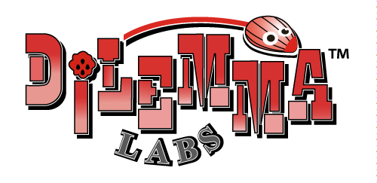
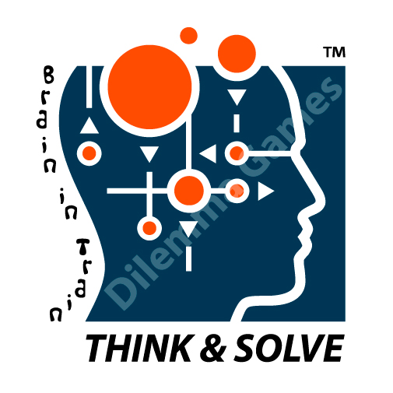

Package Offer
Think & Solve
Educational System

- Exclusivity granted by Dilemma Games Ltd. on Dilemma educational products, dilemma labs and think & solve educational systems in the agreed country/region for 5 years.

- All other buyers from the said country or region will be addressed to the exclusive agent.
- In international exhibitions, our sales staff will present the agent’s details to interested customers form the agreed country or region.
- Each new product developed and/or manufactured by Dilemma Games will be provided with pictures or real samples so that its sales potential in the country or region can be evaluated.

- Product Information and Know-How
- Dilemma Games will supply high quality pictures of products in E-version
- Dilemma Games will supply sizes, weight and instruction manuals of all products in English in e-version.

- Initial training of 8 days with 60 ACADEMIC HOURS, in Dilemma’s training center in CHIANGMAI, THAILAND for 1-20 Trainees. (Transportation and accommodation costs will be borne by the buyer.)

, including:
  - Introduction to Think &Solve educational system
  - Discussion and analysis on the application options of Dilemma Labs
  - Training on instructions and solutions of dilemma products
  - Training on all Dilemma Edu-workbooks
  - Case studies on successful experiences of Dilemma Edu-system in other
countries .

- THINK & SOLVE Educational System
  - Syllabus, in hardcopy
A syllabus including 45 sessions and more than 100 lessons, developed by Israeli educational professionals will be provided.

  - Think & Solve- Introduction to Dilemma Educational Program” which presents the visions and educational targets of the program.

  - Educational workbooks, in hardcopy, including MORE THAN 40 DIFFERENT VOLUMNS
- Hanoi Tower- Step 1
- Soma Cube -Step 1
- Soma Cube -Step 2
- Tangram -I
- Tangram -II
- Tangram-365 puzzles
- Tangram -Step 1
- Tangram- Step 2
- Basic Pento
- Pento- Step 1
- Pento- Step 2
- Pento- Step 3
- Pento- Step 4
- Match Stick Dilemmas
- Magic Squares
- Dilemma Strategic Games
- Dilemma Group Games
- Sudoku and Hitori
- Math Amusements
- Shut the Box
……….

  - “Training courses for Junior Thinking Coaches & training course for Senior Thinking Coaches.

  - Dilemma Games will provide complete set of games for four types of Dilemma Labs ( FOB Bangkok)
      - DILEMMA LAB FOR PRIMARY SCHOOL,
      - MULTI DILEMMA LAB FOR PRIMARY SCHOOL,
      - OUTDOOR PUZZLES & GAMES LAB,
      - JUNIOR HIGH SCHOOLS LAB, with 39 OD Puzzles
*list attached.

  - Within one year after contract signature, Dilemma Games will designate special personnel for all communication matters and proper service or support.

